Architecture and Security Design of Stroke Management and Prediction Web Application Software

Goal: A web application design with the awareness of security and GDPR compliance to collect and manage data of stroke patients, provide clinician access and model-based risk of stroke predictions. The design is based on a defence-in-depth, zero-trust, and secure software best practices.

Note that there will be no prediction features built into this web application in the first instance. However, this will be a feature in the web application in the near future, and we will deploy it to the cloud environment.

Tabular explanation of users of the app.

Stakeholder | Responsibility | Data Managed/Accessed | Data/Information Sensitivity Intensity | Justification
Patient | Records and observes the health system of measurement, including sleep, calories, heart rate, and steps. This data can be shared with their GP. | Personal information (name,  email), consent preferences, health metrics | Special Category | Data relating to health is qualified as a special category and needs enhanced protection under GDPR Article 9  (European Union, 2016)
General Practitioner | Reviews information or data provided by the patient based on the patient's consent for treatment recommendations and advice | Identifiers and health metrics shared by the patient | Special Category | Accessing health-related data requires compliance with GDPR principles of confidentiality and integrity.
Developer | Designs, develops, deploys, and maintains the Health Track Application for patients. | Anonymised test data, application code, bug, and reports | Internal | They are not to access real user data in production. They should use anonymised datasets for testing and debugging.
System Administrator | They manage user accounts, data back-ups, and updates. | User credentials, access logs, and system configurations | Confidential | They handle sensitive information, requiring strict authentication and debugging.
Data Protection Officer (DPO) | Ensures GDPR compliance and adherence, checks data and information handling, and assesses security practices. | Data flow documentation, consent logs, and incident reports | Confidential | They oversee data processing and breach reporting under GDPR Article 32 (European Union, 2016)
Database Administrator (DBA) | Preserves, secures databases, and enforces encryption and access control instruments. | Encrypted health and personal data, system logs | Confidential/ special Category | In charge of making sure data is encrypted both at rest and in transit using secure cryptographic protocols

The app development focuses on 3 main users – Clinicians, that is, medical practitioners. The administrative staff, which includes other users who are not mentioned, can be embedded in the patients.

Functional Requirements

Type | Requirement Description | Implementation/Example
Functional Requirement 1 | The system should allow authorised or required users to register and create a personal account | The registration form collects name, email and password; it validates input before account creation.
Functional Requirement 2 | The system should be planned to allow users to log in and access a dashboard that is personal to them. | Authentication uses email and password via a secure HTTPS connection.
Functional Requirement 3 | The system should record and store users’ daily data details | Mobile sensors synchronise data information to the cloud through the REST API.
Functional Requirement 4 | The system shall allow users to share health information with clinicians upon explicit consent. | Permission management system logs data-sharing preferences and timestamps.
Functional Requirement 5 | The system is designed to allow users to reset their passwords in a secure manner | The email reset link expires after some minutes – between 15 – 20 minutes.
Functional Requirement 6 | Clinicians Portal Access | The system allows registered clinicians to securely access shared patient data through a dedicated web portal using role-based authentication.
Functional Requirement 7 | Alerts and Notifications | The system notifies users via email or app alert regarding significant health trends, system updates, or data-sharing activities
Functional Requirement 8 | Visualisation and Health Information | The system shall present recorded health data to users in an easy-to-read dashboard using charts and summaries of progress over time, with easy comprehension.
Functional Requirement 9 | Data Export and Download | The software app shall allow users to export their health information/data in a standard file format.

Security Requirements:
Integrating security software into the software development process is fundamental to protecting from vulnerabilities and flaws (Manal J., Maha A., Dr. Onytra A. 2024).

Type | Requirement Description | Implementation/example
Security Requirement 1 | All passwords are required to be stored using a salted SHA-256 hash | This aligns with the OWASP Password Storage Guidelines.
Security Requirement 2 | All communications between clients and server shall be encrypted using TLS 1.3. | Ensures confidentiality and integrity of data in transit
Security Requirement 3 | The system is designed to adopt and implement MFA for clinicians and administrative logins. | Ensuring a time-based one-time password and authentication for well-secured data
Security Requirement 4 | Requires that sensitive health data information be encrypted at rest using AES. | In compliance with GDPR. Security of Processing
Security Requirement 5 | The system is designed to maintain audit logs of all data information entry and distribute events. | Ensure the logs record the timestamp, user ID, and action type for non-repudiation.
Security Requirement 6 | The system shall enforce Role-Based Access Control to limit data visibility | There should be distinct responsibilities for the end user, GP, DPO, and administrator.

System Architecture and Secure Design

The 7 Threat Modelling (STRIDE) is adopted, where key possible threats and mitigations are identified in the table below.

STRIDE | Possible Threat | Adopted Mitigations
Spoofing | An attacker steals credentials and uses them to access the web app. | Strong Password, account lockout, Multi-Factor Authenticator (MFA) for admin, and per-request token validation (JWT signed)
Tampering | Patient data or prediction is modified. | Input validation, database integrity checks, Parameterised queries, and Hash-Based Message Authentication Code (HMAC) for audit entries
Repudiation | When a user denies the request for the prediction/deletion of a record | Adopting an immutable audit log with signed-in entries, Hardware Security Module HSM or Key Management Service (KMS)
Information Disclosure | Breach of Data | Transport Layer standard 1.3 (TLS 1.3) or other level of layers for data in transit, Advanced Encryption Standard (AES-256) for data at rest, encryption for Personal Identifiable Information (PII), field level, and least privilege database roles
Denial of Service | Flood prediction endpoint | Web Application Firewall (WAF), rate limiting at API, and circuit breakers
Elevation of Privilege | When a regular user carried out admin actions | Step-up MFA + RBAC + secure objects ACLs

Structure of Threat Modelling

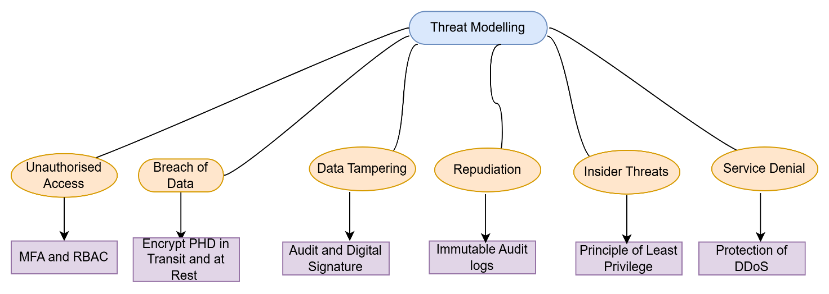
Figure 1

Source: Author’s own

Data Flow Diagram (DFD)

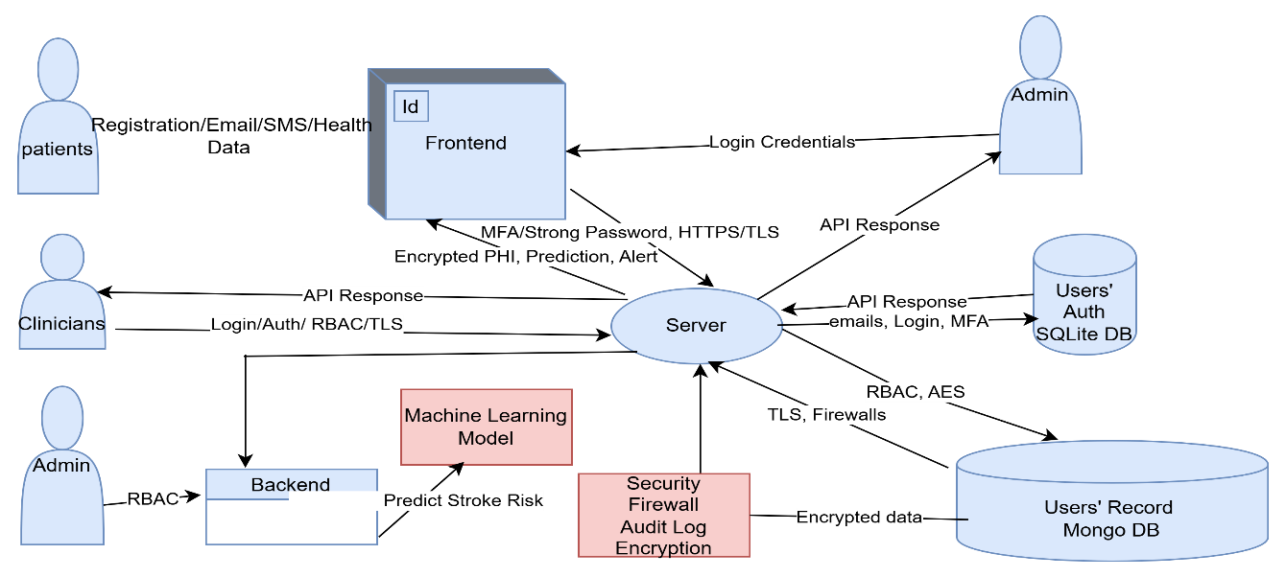Figure 2

Source: Author’s own

Trust Boundaries

- Client Access – edging the internet: Strict CORS, TLS 1.3 + HSTS.
- Edging the backend – WAF, API Gateway Validation, TLS, and Least-privilege DB accounts.
The images used in the web application were generated through brainstorming with ChatGPT (OpenAI, 2025)

Flows Explanation

- Patients register or login as an existing client via the browser (frontend) and use the API Gateway. Patient is authenticated. Security – multi-factor authentication (MFA), Parameterised Queries, HTTPS, TLS 1.3, etc for data in transit, etc.

- Clinicians/Amin login as an already existing client via the browser (frontend) and use the API Gateway. Patient is authenticated. Security – Multi-factor authentication (MFA), RBAC, TLS 1.3 for data in transit, etc.

- Browse: Patience wants to get access to the database through the server– API Gateway. Security: RBAC, TLS, CORS restricted access to frontend.

- Create, Read, Update and Delete (CRUD): browsing through the API patient service to the database, writing immutable Audit/logs to the database. Security: Parameterised queries, RBAC, etc.

- Update from admin via admin portal- ensure audit/logs. Security, immutable logging, MFA setup, modification of approval workflows, and least privilege.

- Prediction: Browser via the API Gateway to the object store and return score to store the result. Security: AES 256 for data at rest, Audit trail, Input validation, and model version logging.

References:

- Murugiah, S., Karen s., & Donna D. (2022). Secure Software Development Framework (SSDF) Version 1.1: Recommendations for Mitigating the Risk of Software Vulnerabilities. National Institute of Standards and Technology (NIST). Special Publication 800-218 Natl. Inst. Stand. Technol. Spec. Publ. 800-218, 36 pages (February 2022). https://doi.org/10.6028/NIST.SP.800-218
- Manal J., Maha A., Dr. Onytra A. (2024). Secure Software Development: Problems and Solutions. International Journal of Intelligent Systems and Applications in Engineering. IJISAE, 2024, 12(4), 4769 - 4776 |4770
- OWASP Secure-By-Design Framework Draft Version 0.5.0 – Initial Community Review (August 2025) OWASP Secure by Design Framework | OWASP Foundation
- OpenAI. (2025). ChatGPT (GPT-5.1) [Large language model]. https//chat.openai.com

